DATA QUALITY

DWBI Test Result
Tamar Tutisani

Contents
DATA QUALITY 1
DWBI Test Result 1
1 Summary 3
2 Test team 3
3 Testing process description 3
4 New defects statistics 3
5 New defects list 3
6 Recommendations 4
7 Attachments 4

Summary
During the DWH reconciliation phase, SQL-based comparison was performed between the Source and Landing layers across all 8 table pairs using dblink, and Python-based business-rule validation was performed on the DWH layer for dwh_clients, dwh_products, dwh_locations and dwh_channels. As a result, 4 schema-level (DDL) defects were identified. Across the LND-layer reconciliation, 197 total row-level discrepancies were identified (of which 187 are records present in Source but missing from Landing), which are consolidated and tracked via 6 LND defect tickets (BG-05 through BG-10)—meaning each bug ticket aggregates multiple underlying row-level discrepancies pointing to a systemic data-loss pattern affecting the tables, rather than being isolated issues. The remaining 10 discrepancies are structural (DDL) issues at the DWH layer.
As this report reflects a point-in-time reconciliation snapshot rather than a full fix-verify cycle, no defects have yet moved to Fixed/Verified status; all 10 remain in Submitted state pending developer assignment.

Test team
Name | Role | Responsibility
Tamar Tutisani | Data Quality Engineer | SQL and Python reconciliation, defect identification and reporting
Mariam Dzindzibadze | Mentor | Review of test deliverables, guidance on scope

Testing process description
Testing was performed against the PostgreSQL databases dwh_src_hw_db (Source) and dwh_hw_db (Landing/DWH/DM), accessed via DBeaver. Source-to-Landing reconciliation was implemented as SQL scripts using the dblink extension to compare all 8 source/landing table pairs, with mismatching rows inserted into lnd.reconciliation_results for review. DWH-layer business rule validation (e.g., IS_VALID flag logic, VALID_FROM/VALID_TO handling, phone number concatenation rules for S2 clients) was implemented in Python via Jupyter Notebook, comparing expected transformation results against actual DWH data. IS DISTINCT FROM was used throughout for nullable-column comparisons to avoid false negatives on NULL handling.

TIMETABLE
Name | Date | Activity | Duration, hours
Tamar Tutisani | 09/09/2026 | SQL reconciliation script development (SRC-LND, 8 table pairs) | 1
Tamar Tutisani | 09/09/2026 | SQL reconciliation execution and results export | 0.2
Tamar Tutisani | 10/09/2026 | Python reconciliation (Jupyter) — business rule validation | 2
Tamar Tutisani | 10/09/2026 | Defect identification and JIRA bug logging | 1
Tamar Tutisani | 16/09/2026 | Test Result Report creation | 2

New defects statistics
Status | Quantity | Trivial | Minor | Major | Critical
Submitted | 10 | 1 | 1 | 6 | 2
Fixed | 0 | 0 | 0 | 0 | 0
Verified | 0 | 0 | 0 | 0 | 0
Reopened | 0 | 0 | 0 | 0 | 0
Declined | 0 | 0 | 0 | 0 | 0

Severity rationale: the two varchar length mismatches are rated Major because they carry a real risk of silently truncating data on load, with no workaround. The CHANNELLOCATION naming typo is rated Minor, it causes confusion but has an easy workaround (using the actual column name). The FIRST_PURRCHASE_DATE typo is rated Trivial, purely cosmetic, blocks nothing.

New defects list
ID | Severity | Summary
BG-01 | Major | Bug: EDW: Products: lnd_s1_products varchar column length mismatch vs. source, risk of data truncation
BG-02 | Major | Bug: EDW: Locations: lnd_s2_locations varchar column length mismatch vs. source, risk of data truncation
BG-03 | Minor | Bug: EDW: Channels: lnd_s1_channels column named CHANNELLOCATION instead of CHANNEL_LOCATION
BG-04 | Trivial | Bug: EDW: Clients: DWH DDL column named FIRST_PURRCHASE_DATE (typo) instead of FIRST_PURCHASE_DATE
BG-05 | Critical | Bug: LND: S1 Sales: 176 mismatched rows between s1_sales (source) and lnd_s1_sales (landing) — root cause: investigate key mismatch or transformation logic
BG-06 | Critical | Bug: LND: S2 Client Sales: 5 mismatched rows between s2_client_sales (source) and lnd_s2_client_sales (landing) — root cause: investigate key mismatch or transformation logic
BG-07 | Major | Bug: LND: S1 Channels: 8 mismatched rows between s1_channels (source) and lnd_s1_channels (landing)
BG-08 | Major | Bug: LND: S2 Locations: 5 mismatched rows between s2_locations (source) and lnd_s2_locations (landing)
BG-09 | Major | Bug: LND: S1 Clients: 2 mismatched rows between s1_clients (source) and lnd_s1_clients (landing)
BG-10 | Minor | Bug: LND: S1 Products: 1 mismatched row between s1_products (source) and lnd_s1_products (landing)

Recommendations
Investigation should prioritize identifying why the SRC→LND load is systematically dropping records, a single root cause likely affects s1_sales, s2_client_sales, s2_locations, and s1_channels alike, rather than treating BG-05 through BG-10 as six independent defects.
Additionally, the 4 DDL-level defects (BG-01 through BG-04) should be corrected before the next reconciliation cycle. It is further recommended that a column-naming and data-type convention be documented and enforced across all Landing-layer table definitions, and that reconciliation queries be incorporated into the standard ETL validation suite to catch similar issues early in future cycles.

Attachments
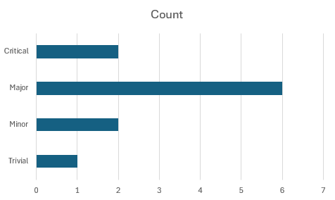
Figure 1. New defects by severity
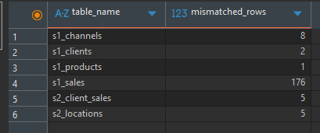
Figure 2. Reconciliation results query output from DBeaver, showing row-level data discrepancies detected during testing.
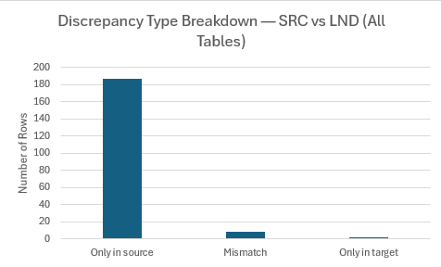
Figure 3. Discrepancy types across SRC vs. LND reconciliation
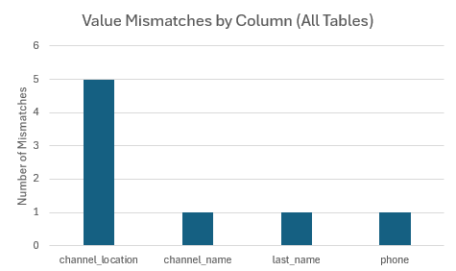
Figure 4. Mismatched columns across all reconciled tables

